EWZSA promotes playing for FUN not competition.
Stats and scores are NOT recorded at this age level.

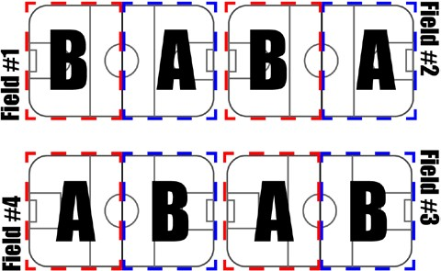
EWZSA U7 INDOOR RULES & REGULATIONS

THE FIELD:

- Half of the indoor field.
- Goals: Provided by the soccer center.
- Both teams will share the same bench and dressing room.
- Retreat Line: to be enforced by coaches. (See below)

THE BALL:

- Size 3.
- Round, spherical, no rips or tears in outer casing.

THE TIME:

- The first 20 minutes will consist of Skills & Drills.
- Followed be a 30 minute game. 2 x 15 minute halves.
- 5 Minutes change over between the next game. If you want a break during the game you will need to shorten the break after practice to 2 minutes.
NOTE: Field time is 55 minutes, no over time is allowed.

NUMBER OF PLAYERS ON THE FIELD:

- Each team will have 4 players and 1 goal keeper on the field at any one time.
- Substitutions: We suggest 2-3 minutes rotating shifts or during any stoppage of play.
- Each player shall receive equal amount of total playing time. PLAYERS EQUIPMENT
- Footwear: Tennis shoes or flat bottom INDOOR soccer shoes. NO CLEATS.
- MANDATORY. Shin-guards and socks covering the shin-guards.
- Jersey/ T-Shirt: Supplied by community or EWZSA.
- NO item of jewelry of any sort will be allowed on the field of play. Medic Alert Bracelets if required must be covered or padded in order to be safe for all players.

START OF PLAY:

- The start of play shall consist of the visiting team starting with the ball at center
- The ball may be played forward or backward at the start of the game

SCORING:

Goals can be scored from anywhere on the field including the crease.

GOAL CREASE:

- The goalie is only allowed to use his/her hands inside the crease. If they wander out of the crease they are to be warned.
- All goal kicks will be kicked from within the goal crease. (top of the crease recommended)

FREE KICKS:

All kicks will be Indirect. Indirect kicks means that the ball must be passed or touched by another player before a goal can be scored. Opposing players must be at least 5 yards away.

- Out-of-Bounds - If the ball goes out the side or hits the netting, the ball will be placed where it exited the field. (The indoor field is split in half so there is a gap on the ends of the removable barrier). The team that did not put it out of play will take the kick.
- Hand-ball - All intentional handballs will result in the coach awarding an in-direct free kick to the non-offending team. Hand-ball within the goal crease will result in a free-kick for the opposing team at the top of the crease.

RETREAT LINE:

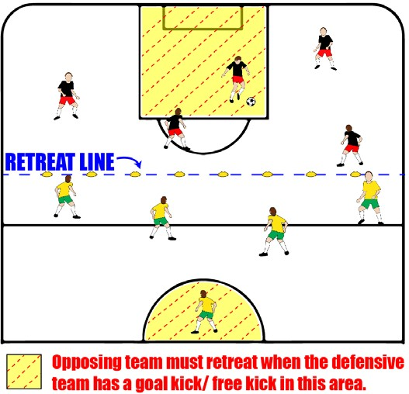
The retreat line will come into effect in two situations during the game (see highlighted area):
- A Goal Kick
- A Free Kick taken from within one’s own goal area.

The opposing team is required to retreat to their half. Attacking player will kick (1-touch) the ball to their teammates. When the ball has left the goal area, the play will resume as normal and the opposing team can move inside the Retreat Line.

If a member of the opposing team interferes with the goal kick before it has left the crease the coach will stop the play and the kick retaken.

The retreat line in mini soccer will be the halfway line. There are no clear markings on the indoor fields for the U7 retreat line. Please do your best to have your players behind the halfway line. (Use of disc cones optional).

See Fair-play below.

AGGRESSIVE BEHAVIOR:

Including- pushing, kicking, punching, hitting will result in an In-Direct free kick to the non-offending team, as well as the player sitting for a minimum of 1 full shift (coaches responsibility to enforce).

THE COACHES:

- There will be one coach from each team on the field. Each coach will take one side. Coaches are to encourage and “referee” their team. (There are no referees at this age). Do not block the goal area.
- One coach or parent from each team will be on the bench to direct the players on to the field.
- Must have a bench parent (mom/dad) for each gender present on mixed teams.

FAIR PLAY:

- Due to some teams not being of equal strength at this age group, once a goalie has possession of the ball the other team must give them half the field (approx.) and cannot chase until the ball has been passed or kicked. This will prevent stronger teams from just crowding the net and keep scoring goals without letting the other opposing players develop a break out or a passing game.

- Due to the creases in the indoor game not being of equal size (on some fields) as well as the boards being only on one side teams will switch sides at half, to give each team an opportunity to have the boards and a smaller crease.

FAQ

WHAT IS MINI SOCCER?

Mini Soccer is a game designed to improve our young players appreciation for the game of soccer. We want them to have fun! The small sided game environment gives these young players “more touches on the ball.” It decreases the barrier of skill and physical developmental differences giving each player the opportunity to improve their soccer skills and physical literacy.

There is 1 game per week, and usually no regular practices. The hour long session consists of 20 minutes Skills & Drills followed by 2 x 15 minute halves. The soccer center books in one hour blocks. This means that all ages (mini to adult) have the field for a maximum of 55 minutes. This allows time for teams to both enter and leave the field. If the Skills & Drills portion goes longer than expected coaches will be required to reduce to the game time. If you require a longer transition time between Skills & Drills and the game please adjust your time accordingly.

There are no referees for the mini program. Each team will have 1 coach present on the field during games. Coaches actively participate with encouragement of positive play and help teach players the rules. There will be lots of reminders of which direction players are supposed to go, and also “No Hands!” It is important to have an assistant coach present with the players on the bench to keep players engaged and ready for substitutions. We also recommend a bench parent be present to keep order on the bench and for any “boo boos”

U7 soccer is played on half of the regular indoor soccer field. There will be 5 players per team on the field at a time – 4 players, and a goalie. Substitutions will be regulated by the coaches (either on the bench or field). We recommend you bring a timer/ stopwatch. Shifts should be approximately 2-3 minutes. To initiate the change coaches can either yell “TIME” or use a whistle. Coaches are encouraged to rotate the players on their team so every player has an opportunity at each position – including goalie.

HOW CAN THEY PLAY A GAME ON ONLY HALF OF THE FIELD?

Edmonton Soccer Facilities will erect a temporary wall through the middle of the regulation field during all mini soccer games. Teams will be scheduled to Side A or Side B. There will be 2 separate games played at the same time therefore there will be 4 teams on a large field. Teams will be required to share a dressing room and bench for their side. Teams are asked to switch attacking/ defending ends (on their side) at half time so that both teams have an equal opportunity to use the built in goal on one side of the field and the temporary goal on the other side.

DO WE KEEP STATS?

No. Mini soccer is a developmental league for fun! No stats are kept at this age group.

